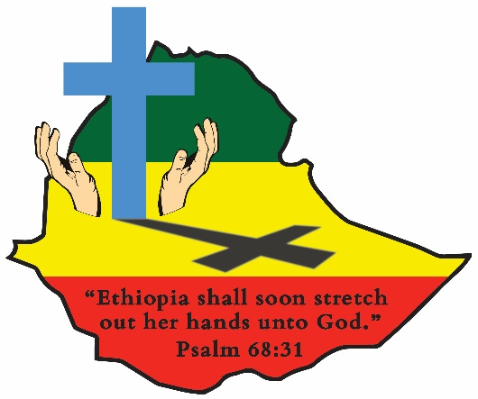
ETHIOPIA GOSPEL OUTREACH
Woodward Park Church of Christ
P.O. Box 3836, Pinedale, CA 93650
559 446-2550

February 24, 2023

TWO YEAR PREACHER TRAINING PROGRAM PLANNING TEAM:
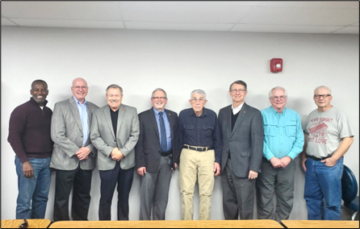
The need for well-trained church leaders is an ongoing issue in congregations all over the world. Leaders in Ethiopia have served well over the last 6 decades, but many of them have gone to their eternal reward and others are physically unable to travel, preach, and serve as they have so faithfully done all their lives. The short term (3½ months) Schools of Preaching have provided preachers and teachers in the local churches, especially in the hundreds of congregations established during the last twenty-two years of drilling water wells and planting new churches in those areas. Short term schools will continue in that ministry. With the changing culture in the exploding populations of the urban areas of Ethiopia it is necessary to prepare for answering the opportunities and challenges for evangelism in the cities. Twenty well-educated Ethiopian brethren have been selected as students in the new two-year program scheduled to start in September. Sunset International Bible Institute (SIBI) will partner with our Ethiopian brethren in establishing and maintaining the new school. Jim Wilson will serve as the full-time coordinator of the school and scheduling teachers from America. Jim and his wife Deborah plan to spend much of their time in Ethiopia during the next several years. This school is a massive undertaking, and we are looking for churches and individuals to join with us in helping with the teaching staff and the financial resources that will be required. We would like to share with you how you can serve us in this great and amazing work. (The new school will be taught using the English language.)
L to R: Habtu Zemech, Doug Reeves, Joe Boe, Tim Burrow, John Ed Clark, Truitt Adair, Dr. Jim Wilson and Kevin Clark
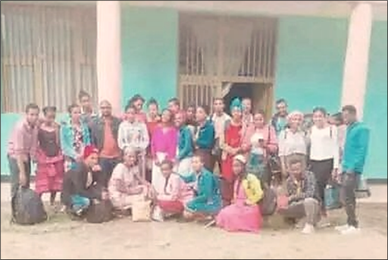
YOUTH GROUP FROM HOSANA READY TO WALK 2 HOURS TO A CONFERENCE AT HANGEDA, SORO. It is a wonderful blessing to see the restored excitement in the churches in Ethiopia after Covid. The church in Hosana is filled with young college students from congregations all over the wide areas of Soro, Kambatta, and Wollieta. They are prepared with food and lots of energy for the long walk ahead of them and for the opportunity of attending the workshop.
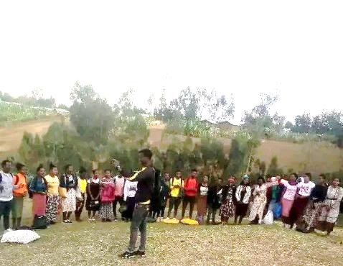
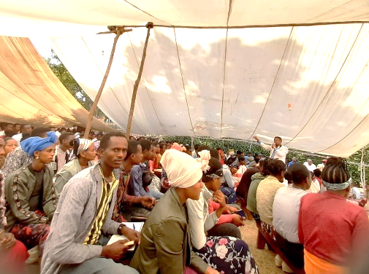
CONFERENCE IN HANGEDA, SORO: Report of Bro. Moges Wolde
“In many places in the countryside, churches organize area wide gospel meetings. This time the Hangeda Church of Christ hosted this three day conference for all the Soro area churches. Many of the participants were preachers, church leaders and many were young members of the church. These kinds of area wide meetings are held once or twice a year and all the Soro area churches are invited. More than 650 people attended. They also have a small size conference every month and the participants are from the neighboring congregations. Because of the economic situation among the people, the participants who come to the meetings bring their own food. Each member brings their “Gabi”. A “Gabi” is a locally made blanket for bed. The food they bring with them is homemade bread, roasted coffee to grind and “kolo” (roasted grain). The hosting congregation is responsible for preparing the visiting participants a place to stay the night, firewood, water for drinking and cooking. The participants stay in the homes of the host congregation members. The program started Friday evening for two or three hours. It continued all day Saturday and through the Sunday Morning worship. When the worship program was dismissed, visitors returned to their homes. When they are together in the conference, they use the time to pray, study the word of God with different preachers and teachers, singing together and sharing with each other about the gospel ministry in each area. Sisters who have come with each group take the responsibility of preparing food and making coffee for their group members. This is the way the churches are able to conduct such kinds of big conferences now in the countryside, especially in the Soro area. I have attached pictures of some young members of the church from the Hosana congregation on the way to the Hangeda conference and another picture taken while the conference is going on. I received cell phone pictures from some of the brothers from Hosana. May God bless all who Labor Day and night for the Kingdom’s cause!!” Moges
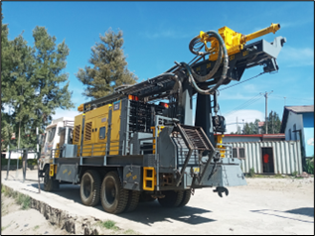
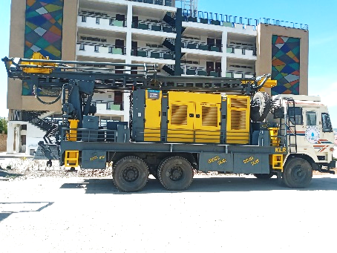
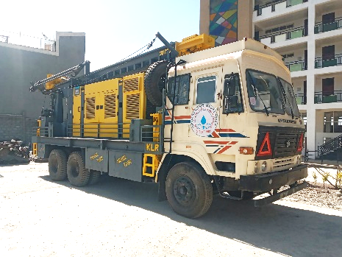
NEW DRILLING RIG RECEIVED AND DELIVERED DUTY FREE:
The new drilling rig was released to us duty free and is ready to be put into service. Monte Hininger will be going to Ethiopia to help the crew drill at least two new wells on the Deaf School Compound in Addis Ababa and then be with them when it is taken to the Sidama area as the new 60 well drilling starts. Monte and the crew will also update and repair our old Schramm rig, which will serve as a backup. We praise God for making this possible!
Thanks to each of you who read this report and faithfully pray for and support the Lord’s work in Ethiopia. Kevin and John Ed Clark

